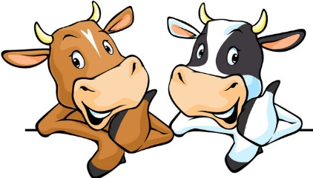
2023 Dairy Days
Cattle Show Information
Guidelines and Registration Form

The 2023 Dairy Days Cattle Show hosted by Juda for the Green County Ag Chest is scheduled for Saturday, June 17th at the Green County Fairgrounds in Monroe.

If you plan to enter the 2023 Dairy Days Cattle Show, please read the guidelines below and send your completed registration form to dairydayscattleshow@gmail.com or mail it to the following:

Green County Dairy Days Committee
c/o Phil and Laura Vosberg
W5603 Center Rd.
Monroe, WI 53566

***Registrations must be received by June 1, 2023!***

Guidelines

Exhibitors will receive a complimentary t-shirt upon check-in (see registration form).
Showmanship classes will start at 11:00 a.m. The show will take place in Barn 7, also known as the “Show Barn”. Judging begins with grade animals at the conclusion of Showmanship, followed by Registered animals.

- Participation is open to youth from 3rd grade through 20 years old as of January 1, 2023 from Green County and surrounding counties.
- Exhibitors must exhibit as a member of a recognized youth organization.
- Exhibitors may exhibit up to four animals.
- ALL animals must be checked by the on-site Veterinarian prior to entering or being tied in any barn.
- Original registration papers are needed at check-in at the show.
- Dairy cattle class listings are in alignment with the Green County Fair dairy classes.
- Cattle classes may be split based on final entries.
- A registered Premise ID will be required on all entry forms.
- All exhibitors are responsible for removing and taking all bedding that they bring in.
- All exhibitors, friends, and relatives must enter the fairgrounds through the east gate. Please note that there may be other events going on at the fairgrounds on that day. All exhibitors’ and spectators’ vehicles should be parked on the north side of the Fairgrounds road (barn side).

Animal Health Information and Veterinary Check-In Procedure

For detailed information on health guidelines, please refer to the 2023 Green County Junior Fair Book found online at greencountyfair.net/pageserver/fairbook. State health regulations require that ALL dairy animals that are exhibited at cattle shows in Wisconsin MUST be accompanied by some type of identification. Identification may be in the form of registration papers, a tattoo from a breed association, a metal Wisconsin ear tag, or any herd tag. It is against state health regulations to bring animals that are infected with ringworm, warts, or mange to the Green County Dairy Days Cattle Show. Any cattle found with ringworm, warts, or mange will be ordered to be removed from the premises immediately and will not be allowed into the barns or the show.

Pre-show Schedule:

- 7:30 a.m. to 10:30 a.m.
  - Animals may begin arriving at the fairgrounds. Unloading will take place on the south end of Barn 7.
  - All animals MUST be checked by the on-site Veterinarian before entering any barns and being tied. Vet checks will be held on the south end of Barn 7.

- 7:30 a.m.to 10:30 a.m. - All exhibitors must check-in at Barn 7

  - Show registration papers
  - Pick up t-shirt and back tag numbers
  - Inform registration staff of any scratches or vet-excused animals

**REMINDER: All exhibitors are responsible for removing and taking all bedding that they bring in for their animals.**

