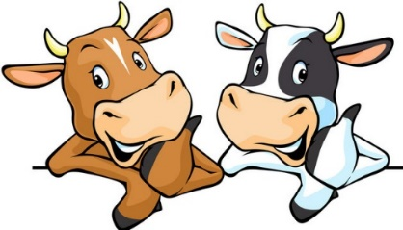
2023 Dairy Days
Cattle Show Registration Form
(Please print legibly)

Name of Exhibitor ______________________________________ Grade (as of January 1, 2023) _____________
Address __________________________________________ City ______________ State ______ Zip __________
Name of 4-H Club, FFA Chapter, or other Youth Organization __________________________________________
Premise ID No. _____________________________ Phone Number _____________________________________
Email _______________________________________________________________________________________
T-shirt Size (1 per exhibitor): Youth S M L Adult S M L XL XXL

Showmanship – Please check the box to participate. Grade as of January 1, 2023: _____________

Cattle Registration (Up to milking age). Exhibitors may show up to four (4) animals.
Name of Animal: Registered Grade (circle one)
Birthdate: Owned Managerial (circle one)
Class No. Reg. #/Ear Tag: Breed:

Name of Animal: Registered Grade (circle one)
Birthdate: Owned Managerial (circle one)
Class No. Reg. #/Ear Tag: Breed:

Name of Animal: Registered Grade (circle one)
Birthdate: Owned Managerial (circle one)
Class No. Reg. #/Ear Tag: Breed:

Name of Animal: Registered Grade (circle one)
Birthdate: Owned Managerial (circle one)
Class No. Reg. #/Ear Tag: Breed:

