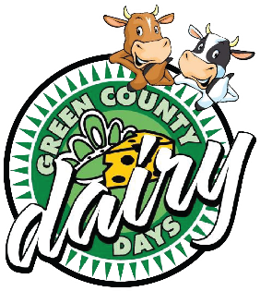
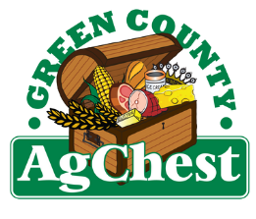
2026 Green County Dairy Days
Ag Awards Nomination Form

Each year, the Green County Ag Chest and the Green County Dairy Days Committee honor men and women in agriculture during the Dairy Days Queen's Banquet. To nominate someone for an Ag Award, please choose from the categories below and provide the requested information about the nominee.

This nomination is for the following category:

____ Agri-Business Woman of the Year (18 to 39 years old)
____ Agri-Business Woman of the Year (40 and over)
____ Active Ag Couple of the Year

Nominee Information:
Nominees must live, work, or own property in Green County. Please note: previous winners are not eligible.

Name Phone Number

Address City, State, Zip

Spouse

Children

In a separate document, please provide the following information about your nominee(s).

1. Give a brief background of the nominee.

2. Why do you believe this individual or couple should be recognized for their efforts and involvement in agriculture?

3. What groups is the nominee actively involved in within their community, church, or other organizations? Please list the groups and what the nominee has done in them.

4. What else should we know about the character of the nominee?

Awards will be presented during the Dairy Days Queen’s Banquet on June 19, 2026 in Albany. Official invitation to follow. Please send this page along with your separate document to the following address:

Green County Ag Chest
P.O. Box 533
Monroe, WI 53566
**All entries must be postmarked by June 1, 2026.**

