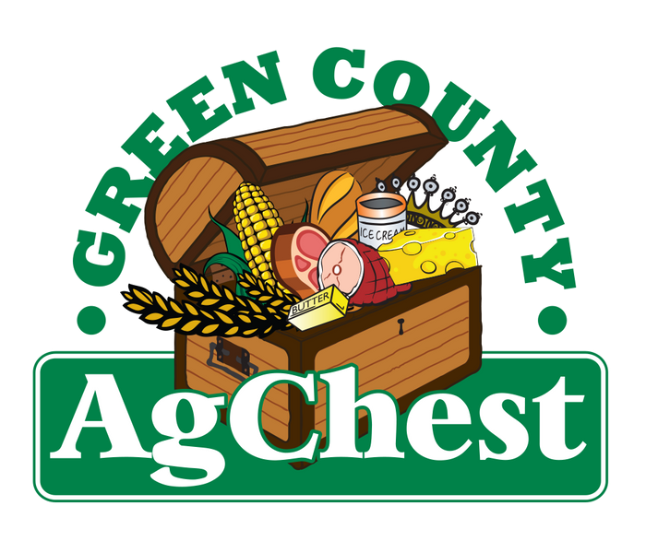
2026 Green County Breakfast on the Farm
Craft/Vendor/Education Booth Registration & Release of Liability

The 2026 Green County Breakfast on the Farm will be held at Pinnacle Dairy Farm LLC. located at N4201 Decatur-Sylvester Rd, Brodhead, Saturday, May 30, 2026. (NOT MEMORIAL WEEKEND)
Booths are limited to a 10'x10' space and cost $35. Please note, due to limited space, there will not be access to electricity or shelter in the crafters’ area. Vendors may bring in their own 10’x10’ pop-up tent if they so choose. Non-profit organizations are eligible to register at no cost but must provide proof of non-profit status with this registration form. If you need a table, note it on your entry form.

All crafters may set-up on Friday, May 29th between 3 PM and 7 PM. Crafter's vehicles will be able to park near their display Saturday, May 30th as long as they are there by 5 AM. After that time, you will need to park in Monroe or Albany and take the bus. There is no parking on the farm! Please contact the BOTF Committee with questions at greencountyBOTF@gmail.com.

If you wish to host a crafter's booth at the breakfast on the farm, please complete this form and mail it, along with the registration fee, to:
Green County Ag Chest BOTF
P.O. Box 34 Belleville, WI 53508

**All entries must be postmarked by May 12th. Check should be made out to the Green County BOTF.

Name Phone

Address City State Description of craft being sold
Email

WAIVER OF LIABILITY
By signing below, you understand and hold harmless the Green County Ag Chest, Green County Breakfast on the Farm Committee, and its partners and affiliates for any accidents, injury, or loss sustained while participating in the 2023 Breakfast on the Farm event.

Signature Date

