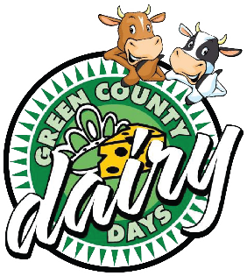
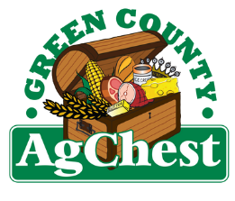
2026 Green County Dairy Days

June 13th (Cattle Show)
June 19th (Queen & Princess Crowning Banquet)

Green County Dairy Days will be hosted
by Albany this year!

Dairy Days will kick off in June with the Green County Dairy Days Cattle Show. On Saturday, June 13th, the Green County Dairy Days Cattle show will commence at the Green County Fairgrounds in Monroe. Youth from 3rd grade through one year beyond high school graduation from Green County and the surrounding area will proudly present their dairy heifers, showing their passion and love for agriculture. The show will begin at 11:00 a.m. with Showmanship classes, followed by Grade and Registered heifer judging.

Because of your generous donations, we are able to offer a fee-free cattle show to area youth; no fees are charged to any youth participating in this show. In addition, the participants receive premiums to help support their love of showing their heifers, as well as awards to commemorate their efforts in the show.

On Friday, June 19th, eleven young women from our Green County communities will spend the day bonding and going through interviews in hopes of representing Green County as the next Green County Dairy Queen or Green County Dairy Princess. Join us at the Albany Lions Club for Moo-Tails beginning at 6:00 p.m. and the “Big Question” at 6:30 p.m., followed by the banquet at 7:00 p.m. Tickets are $10.00 for the evening. The 2026-2027 Green County Dairy Queen and Green County Dairy Princess will be crowned at the end of the evening.

The Green County Dairy Days Cattle Show and the Queen and Princess Crownings are open to everyone and are a great way to show your support for Green County area agriculture and its youth.

Hosting these events takes a great deal of planning and resources. We would be very grateful if you would consider donating to help support our 2026 Green County Dairy Days festivities. With your donation, you will be listed on our programs, our Facebook pages (“Green County Dairy Queens” and “Green County Dairy Days Cattle Show”), and our Sponsor Board, which is prominently and proudly displayed at our cattle show for all to see, showing you as a supporter of Green County and area youth in agriculture. Please support area youth in agriculture and help us make this year’s event a huge success!

All donations may be sent to the following:

Green County Dairy Days Committee
c/o Laura Vosberg
W5603 Center Rd
Monroe, WI 53566

If you have questions, please send an email to the following:
dairydayscattleshow@gmail.com
or text Laura at 608-558-6369.

Thank you!

***Donations to the Green County Ag Chest are tax-deductible.***
Thank You for
Your Support!
2026 Green County Dairy Days
June 13th (Green County Dairy Days Cattle Show)
June 19th (County Queen & Princess Crowning Banquet)

Yes, I want to support Green County and area youth in agriculture by donating to the 2026 Green County Dairy Days Cattle Show Queen and/or Green County Dairy Days Crowning Banquet.

Business Name: ____________________________________________________________

Contact Name: _____________________________________________________________

Address: __________________________ City: ______________ State: ____ Zip: ________

Phone: _______________________ Email: _______________________________________

With your donation, you will be listed on our programs, our Facebook pages, and our Sponsor Board, which is prominently and proudly displayed at our cattle show, showing you as a supporter of Green County and area youth in agriculture. Please indicate your donation category preference and we will do our best to accommodate your wishes:

Donation Amount: $ _______________

County Dairy Queen and Princess Crowning Banquet

Dairy Days Cattle Show

General Funds Champion Sponsor

Trophies & Awards Showmanship Class Sponsor

Specific sponsorship: __________________________________________

Please make all checks payable to Green County Ag Chest and send it with this form.

Thank you for supporting Green County and area youth in agriculture! We greatly appreciate your generosity. We hope to see you at the 2026 Green County Dairy Days festivities!

The 2026 Green County Dairy Days Committee

